MUNAZA MUNIR 03220147287 70146760@student.uol.edu.pk

ROBOT FRANEWORK TEST PASSED SUCCESSFULLY
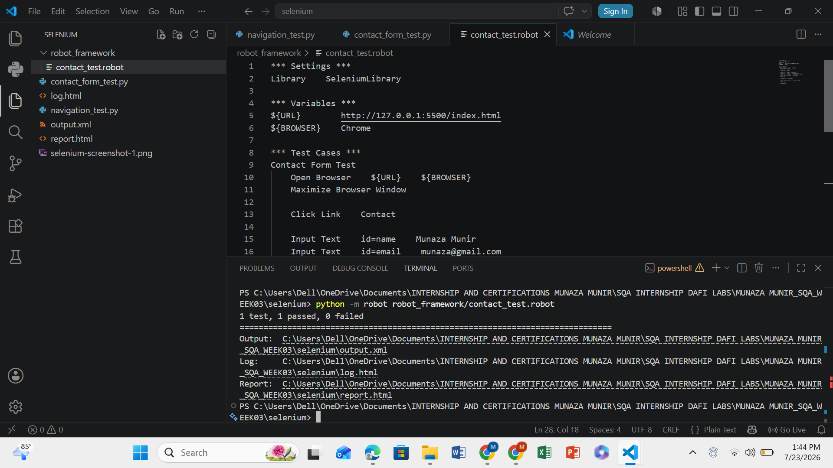

Robot Framework Automation Report

Session 3 – Task 3

Robot Framework Automation Practice

1. Objective
The objective of this task was to gain practical experience with Robot Framework, a keyword-driven automation testing framework. The task involved installing Robot Framework and SeleniumLibrary, creating a basic automation project, implementing an automated test scenario, and understanding how keyword-driven testing differs from script-based automation using Selenium.

2. Tools and Technologies Used
Tool | Purpose
Visual Studio Code | Code editor
Python | Programming language
Robot Framework | Keyword-driven automation framework
SeleniumLibrary | Browser automation library for Robot Framework
Google Chrome | Browser used for testing
Selenium | Browser automation engine
Live Server | Local web server
HTML | Website under test
JavaScript | Website functionality

3. Software Requirements
Before creating Robot Framework tests, the following software was required:
- Python
- Visual Studio Code
- Robot Framework
- SeleniumLibrary
- Google Chrome
- Selenium
- Live Server Extension

4. Project Setup
The Robot Framework test was created inside the existing Selenium project.
Project structure:
selenium
│
├── navigation_test.py
├── contact_form_test.py
│
└── robot_framework
└── contact_test.robot

5. Installing Robot Framework
Robot Framework was installed using Python's package manager.
Command used:
python -m pip install robotframework

6. Installing SeleniumLibrary
To automate browser interactions, SeleniumLibrary was installed.
Command used:
python -m pip install robotframework-seleniumlibrary
SeleniumLibrary provides built-in keywords for browser automation, such as opening browsers, clicking elements, entering text, and verifying page content.

7. Creating Robot Framework Test File
A folder named robot_framework was created.
Inside this folder, a Robot Framework test file was created.
contact_test.robot

8. Website Used for Testing
The Personal Profile Website created during previous internship tasks was used for automation.
Website URL:
http://127.0.0.1:5500/index.html
The website was executed using the Live Server extension in Visual Studio Code.

9. Robot Framework Test Scenario

Scenario
Contact Form Automation Testing

Objective
To verify that a user can successfully submit the Contact Form using Robot Framework automation.

Test Steps
- Open Google Chrome.
- Open the Personal Profile Website.
- Maximize the browser window.
- Click the Contact navigation link.
- Enter Name.
- Enter Email.
- Enter Message.
- Scroll to the Submit button.
- Click the Submit button.
- Verify that the success message is displayed.
- Close the browser.

10. Keywords Used
The following Robot Framework keywords were used:
Keyword | Purpose
Open Browser | Launch Chrome browser
Maximize Browser Window | Maximize browser
Click Link | Navigate to Contact section
Input Text | Enter text into input fields
Scroll Element Into View | Scroll to Submit button
Click Button | Submit the form
Element Should Be Visible | Verify success message
Sleep | Pause execution
Close Browser | Close browser after execution

11. Issue Encountered
During the first execution, Robot Framework generated the following exception:
ElementClickInterceptedException
The Submit button could not be clicked because another element overlapped it.

12. Solution Applied
The issue was resolved by scrolling the Submit button into the visible area before clicking it.
Robot Framework keyword used:
Scroll Element Into View id=submitBtn
After applying this keyword, the automation executed successfully.

13. Test Result
Scenario | Description | Status
Contact Form Automation | Verify successful form submission using Robot Framework | PASS

14. Output Files Generated
After execution, Robot Framework automatically generated the following files:
File | Purpose
output.xml | Stores execution results
log.html | Detailed execution log
report.html | Summary report of test execution
These files provide detailed information about the executed test and can be used for analysis and reporting.

15. Learning Outcomes
During this task, the following concepts were learned:
- Installing Robot Framework
- Installing SeleniumLibrary
- Creating Robot Framework test files
- Using keyword-driven automation
- Automating browser interactions
- Filling web forms automatically
- Verifying expected results using Robot Framework keywords
- Handling click interception issues by scrolling elements into view
- Understanding Robot Framework execution reports

16. Conclusion
This practical activity provided hands-on experience with Robot Framework and keyword-driven test automation. A contact form scenario was successfully automated using SeleniumLibrary keywords without writing extensive programming logic. The task demonstrated how Robot Framework simplifies automation through readable, reusable keywords while still providing reliable browser automation. It also introduced built-in reporting capabilities, making Robot Framework an effective choice for creating maintainable and easy-to-understand automated test scripts.

